**RECOMMENDER SYSTEM :**

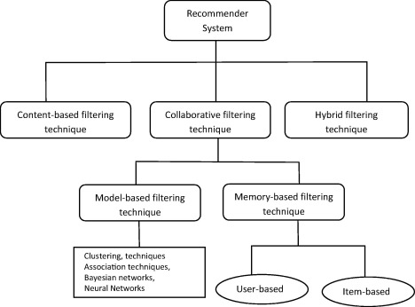

**What a recommender system really does?**

**A friendly explanation,**

Given any reasonable similarity function between items,  a recommender system presents relevant items to a user. This similarity function between 2 items could be common users that have interacted with those items in the past, similarity in their attributes, similarity in  context in which they are used, and so on.

At their core, recommendation systems are nothing but similarity hunters. Depending on how you define "similarity" between two "items", you can a range of applications for these systems.  The only requirement to make a recommendation system worthwhile (compared to other techniques) is that the number of items should be big, and typically, sparse.

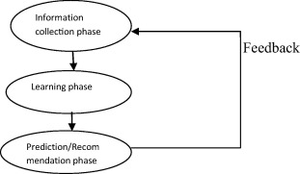

**APPLICATIONS :**

* **“Improving with use” (retention):**You’re much less likely to switch to a Netflix competitor when Netflix has such a wonderful sense of which movies and shows you might want to watch next (i.e. they “know you so well”). Because most of Netflix’s revenues come from a fixed-rate recurring billing model subscription, the company’s biggest ROI “win” with recommendation systems is retention.
* **Improving cart value:** Amazon’s quick delivery and emphasis on customer service has earned them millions of customers. Recommendation engines play a role not only in helping customers find more of what they need (and see Amazon as an authority), but these systems also improve cart value. If Amazon doesn’t have to pay much more for shipping to send you two or three times as many products, their profit margins improve.
* **Improved engagement and delight:**YouTube has subscription options, but the majority of the firm’s revenues are driven through advertisements placed across its wide array of video properties. The company makes more money when users come back time and time again. YouTube doesn’t optimize for short-term view length, as this might encourage pushy or flashy tactics that wouldn’t genuinely delight users. Instead, the service aims to encourage long-term use, because advertising views is the ROI that these systems serve at YouTube. Facebook is another obvious example of a similar application of recommendation engines.

**Also, Applications of Recommender Systems in various domains :**

* **Purchase:** People who bought X also bought Y

**Business case scenario :** Consider a scenario of an e-commerce website which sells thousands of smart phones. With growing number of customers every day, the task in hand is to showcase the best choices of smart phones to the users according to their tastes and preferences.

* **Experience:** People who read/watched/enjoyed X also enjoyed Y

**Use Case :** Mobile Content Recommendation Sytem

**Business case scenario :** To increase the user friendliness in terms of the content and services, the correct delivery system has to be fitted for each user and the appropriate content must be delivered to each user at the appropriate time and using appropriate means. However, with the present mobile system, there are limitations to providing an integrated system. Furthermore the current mobile system could not provide the environment for more intellectual services. Thus, it is necessary to have a system that can provide identification between user preferences and user relationships, and provide the information to each user’s service in analyzed and standardized way to supply customized contents and services.

**Solution :** Individualized user preferences are identified through analysis of both wired and wireless use histories. Identified preferences are used to determine suitable content recommendations using techniques of content-based filtering and collaborative filtering. It enables content recommendations suitable to the user’s existing situation by application of recommendation policies according to the user’s current situational information such as user preference, time, place, weather, schedule, etc. Through reasoning of the social relationship between users, stereotypes of subscribers whose preference could not be retrieved can be assumed and recommended, or contents of other subscribers who are related to the current subscriber are recommended.

* **Location:** People who have been at/ate at/stayed at X also went to Y
* **Current website:** People who come to this website also browse Y
* **Education:** People who knew about/worked on/learnt/ X also learnt Y
* **Hiring:** People who have skills like your employees
* **Recipes:** People who cooked X also cooked Y
* **Context:** People in X mood, at Z time do activity Y more
* **Finance:** Stocks bought by successful X people
* **Popularity:** Items popular in the last hour, week, year
* **Promotions:** People who should be offered promotion Y
* **Social:** People/friends are talking about item Y
* **Health:** People who are healthy do Y more
* **Drugs:** People with X characteristics respond to drug Y better
* **Ideas:** Past ideas/patents/companies related to your idea
* **Law:** Past cases related to your current lawsuit
* **Law Enforcement:** People similar to X are likely to commit a crime Y

Showcasing use case of RS:

<https://www.slideshare.net/MrChrisJohnson/interactive-recommender-systems-with-netflix-and-spotify/27-Section_name_27SmartBox_fully_interactive>